Annual Report 2026

(A review and analysis of 2025)



Sandersville Police Department
130 Malone Street

Sandersville, Ga. 31082
Table of Contents

The Chief of Police 4
Sandersville Police Department BIO 5
Deputy Chief 6
Use of Force Analysis 7-9
Road Patrol Supervisors 10
Road Patrol Officers 11
Part-Time Officers 12
Vehicle Pursuit Analysis… 13-15
CID Detectives 16-17
CID Cases 18
Traffic Unit……………………………………………19-23
Animal Control Officers 24-25
Animal Control Cases 26
Certification Manager 27-28
Administrative Assistance 29
Community Relations 30-34
Police Officer’s Prayer 35

Chief of Police Victor K. Cuyler
Chief Victor K. Cuyler serves as the Chief of Police for the Sandersville Police Department and brings more than three decades of dedicated public service, leadership, and community commitment to the position.
A lifelong resident of Washington County, Chief Cuyler is a proud graduate of Washington County High School. Following graduation, he answered the call to serve his country by enlisting in the United States Marine Corps, where he served honorably from September 1983 to September 1990. His military career was marked by dedication, discipline, and professionalism, culminating in an Honorable Discharge.
Chief Cuyler began his law enforcement career with the Sandersville Police Department on March 23, 1992. Throughout his distinguished tenure, he has demonstrated an unwavering commitment to public safety, professional excellence, and community-oriented policing. He is a certified law enforcement instructor through the Georgia Peace Officer Standards and Training Council, where he has contributed to the development and training of law enforcement professionals across the State of Georgia.
Committed to lifelong learning and professional development, Chief Cuyler attended Georgia Military College, earning an Associate Degree in General Studies. He further enhanced his executive leadership skills by completing the prestigious Chiefs School through the Georgia Association of Chiefs of Police, preparing him to lead modern law enforcement organizations with integrity, accountability, and vision.
In addition to his law enforcement career, Chief Cuyler is an ordained minister of the Gospel of Jesus Christ and serves as pastor of Springfield Fellowship Church. His faith-based leadership and dedication to service have made a lasting impact both within the community and beyond.
Chief Cuyler is the proud father of five children and remains deeply committed to the citizens of Sandersville and Washington County. His career reflects a steadfast dedication to serving others through military service, law enforcement leadership, community engagement, and ministry. Under his leadership, the Sandersville Police Department continues to uphold its mission of protecting and serving with professionalism, compassion, and integrity.

Sandersville Police Department BIO/ Demographics
The Sandersville Police Department is a law enforcement agency that works for the safety and protection of citizens. It maintains a criminal investigation division that checks crime against persons and property. The department operates a patrol division that conducts
accident investigations and enforces traffic law. The Sandersville Police Department
organizes various programs for senior citizens. It focused on preventing the usage of drugs and also maintains a records division. The department coordinates response to emergency and nonemergency situations and handles cases related to theft and homicide. The
Sandersville Police Department is located in Sandersville, Ga.

Sandersville was settled around 1783 by Revolutionary War veterans who were awarded grants to Creek and Cherokee lands. Once known as “White Ponds,” the town grew up around the intersection of two Creek Indian trails and included a trading post owned by Mark Saunders (for whom the town was later named, with a spelling change). Saunders was instrumental in the town's early history.
The estimated population in 2017 was 5,571, just under the official 2010 census count. Compared to the rest of the country, Sandersville's cost of living is 20.79 percent lower than the U.S. average, making it a great place to live, work, own and operate a business and raise a family. The median home cost in Sandersville is $100,000.

Sandersville and Washington County have an active Historical Society. The county is known
as The Kaolin Capital of the World for its vast deposit of kaolinite, and we celebrate a Kaolin Festival every year. We are the home of the official Georgia Plate.
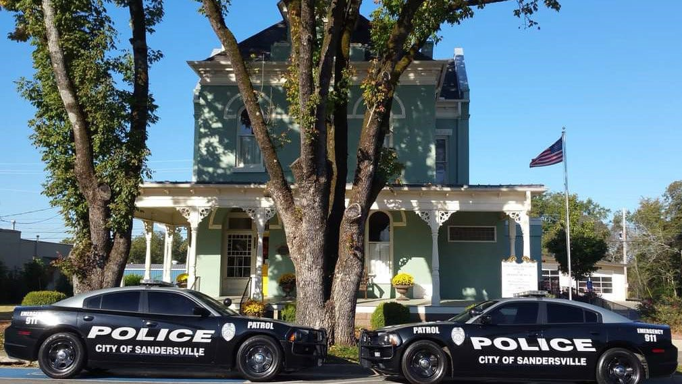

Deputy Chief Brian Shelton

Deputy Chief Brian Shelton is a seasoned law enforcement professional whose career is defined by leadership, operational excellence, and a strong commitment to public service. He began his law enforcement career in 2009 with the Sandersville Police Department and has since accumulated extensive experience in patrol operations, training, supervision, and executive leadership.
Throughout his tenure with the Sandersville Police Department, Deputy Chief Shelton steadily advanced through the ranks based on his dedication, professionalism, and proven leadership abilities. He served as Patrol Sergeant and later Patrol Lieutenant, while also fulfilling critical roles as a Field Training Officer, Shift Supervisor, and Shift Commander. These assignments provided him with comprehensive experience in patrol management, officer development, policy implementation, and daily operational oversight.
In addition to his service with the Sandersville Police Department, Deputy Chief Shelton has worked with several law enforcement agencies throughout Georgia, gaining diverse experience across multiple disciplines of public safety. Prior to returning to Sandersville, he served with the Georgia Public Safety Training Center (GPSTC), where he advanced to the rank of Captain. During his tenure at GPSTC, he played a significant role in law enforcement training and professional development, helping prepare and mentor officers from agencies across the state.
Deputy Chief Shelton is a state-certified law enforcement instructor and holds multiple instructor certifications in specialized areas of law enforcement training. His passion for education and officer development has made him a respected leader and mentor within the law enforcement community.
Committed to professional growth and executive leadership, Deputy Chief Shelton successfully completed the Chief Executive Training Program through the Georgia Association of Chiefs of Police, a premier leadership program designed to prepare law enforcement executives for the challenges of modern policing.
As Deputy Chief of Police for the Sandersville Police Department, Shelton serves as the Chief of Police’s principal assistant and is responsible for helping oversee all departmental operations, personnel, training initiatives, and administrative functions. His leadership supports the department's mission of providing professional, ethical, and community-focused law enforcement services to the citizens of Sandersville and Washington County.
Deputy Chief Shelton’s career reflects a steadfast commitment to excellence, integrity, and service. Through his extensive operational experience, training expertise, and executive leadership, he continues to play a vital role in advancing the mission and effectiveness of the Sandersville Police Department.

Use of Force Analysis
The Sandersville Police Department responded to 7475 calls for service during the period of 01/01/2025 and 12/31/2025. During this same time frame the department made a total of arrests.
The demographics of the arrests are broken down as sixty (60) were black males, ten (10) were white males, seventeen (17) were black females, six (6) were white females, one (1) were classified as others, and five (5) were juveniles.
**Demographic arrests do reflect multiple arrest of the same offender**

Table 1 (Arrest Demographics)

RSA | 0-17 | 18-29 | 30-39 | 40-49 | 50-59 | 60-69 | 70+ | Total
Black Males | 0 | 17 | 12 | 11 | 12 | 8 | 0 | 60
White Males | 0 | 3 | 2 | 2 | 1 | 2 | 0 | 10
Black Females | 0 | 11 | 4 | 2 | 0 | 0 | 0 | 17
White Females | 0 | 2 | 2 | 2 | 0 | 0 | 0 | 6
Juveniles | 8 | 0 | 0 | 0 | 0 | 0 | 0 | 5
Other | 0 | 1 | 0 | 0 | 0 | 0 | 0 | 1

The Sandersville Police Department reported hundred and fourteen (114) use of force reports for the calendar year 2024. The use of force is broken down into (4) incidents involving the use of the Taser (Electronic Control Device), (1) incident that involved OC Spray, (1) incidents that involved the use hands, and (7) incidents that involved the use of firearms.

Table 2 (Use of Force)

YEAR | Taser | Hands | Firearms | OC Spray | Total
2023 | 4 | 1 | 7 | 1 | 13
2024 | 4 | 2 | 8 | 0 | 14
2025 | 6 | 2 | 1 | 0 | 9

There were significant changes in the number of uses of force incidents from 2024 to 2025. The primary use of force remains the deployment of the taser.
Analysis
The Sandersville Police Department remains dedicated to review and analyze the officer’s use of force reports to identify training deficiencies or signs of early warning. The use of force review allows the department to ensure that the officers are trained properly and prepared to serve the public in a professional manner. The department will continue to conduct a supervisory review of every use of force incident to ensure that the use of force complies with federal, state, and local laws, as well as department’s Standard Operating Procedures.
The State requires that all certified officers receive annual training on “Use of Force and De-escalation” and “Community Policing”. The Sandersville Police Department is voluntarily participating in the State Certification program developed by the Georgia Association of Chiefs of Police. This accreditation program further requires annual training on the agency’s use of force policy, constitutional and legal limitations on the use of deadly force, agency’s deadly force policy, biased based profiling, and dealing with mentally ill or persons with diminished capacity, just to name a few.
The Sandersville Police Department is aware of the need to understand and be prepared to address the needs of the mental health consumers in our community. The Department is dedicated to getting all of our officers to participate in Crisis Intervention Team (CIT) training, GCAL- Georgia Crisis and Access Line and Mental Health Crisis Training.

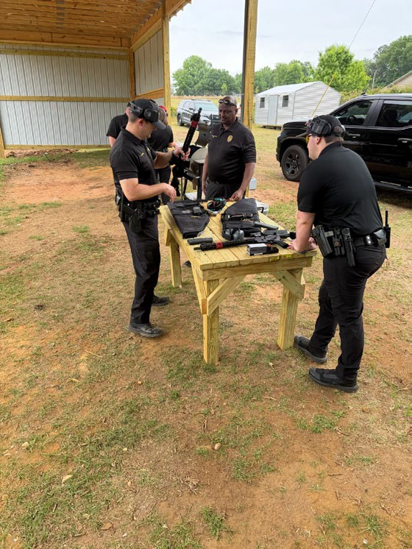
There are significant changes in the departments use of force from the 2022 to 2023 trend.
The department will continue to use a multi-step review of every use of force event to identify the need for policy adjustments or addition training.
There has been a increased in the training department. The Training Captain is part of the use of force review process, which allows him to identify training needs such as proper application of taught techniques, understanding of policy, and areas that may need greater clarification.
The need for more hands-on training has been identified and the Chief along with the training Captain is in the process of developing a plan to incorporate this training. The training Captain has also begun to include scenario-based training into as many areas of training as possible to reinforce prior training and better develop the ability to think under stress.

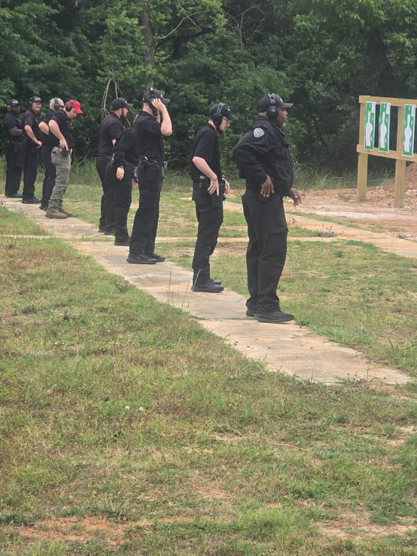
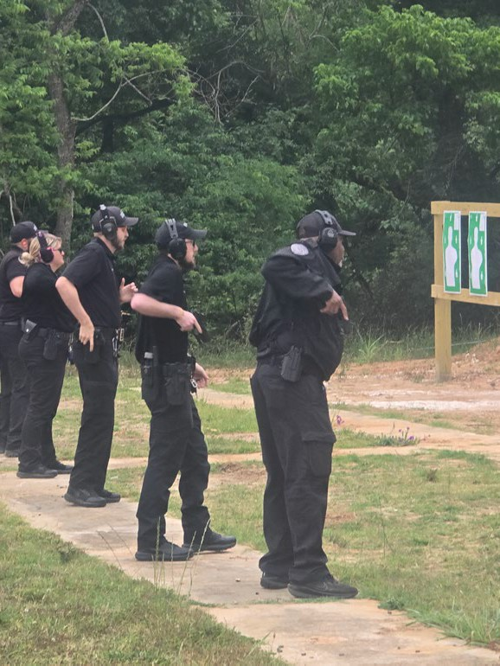
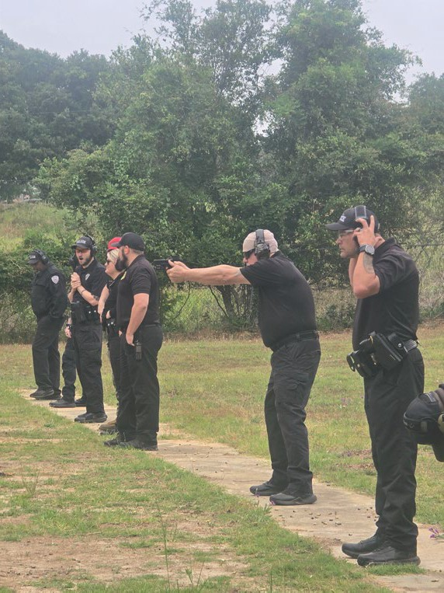

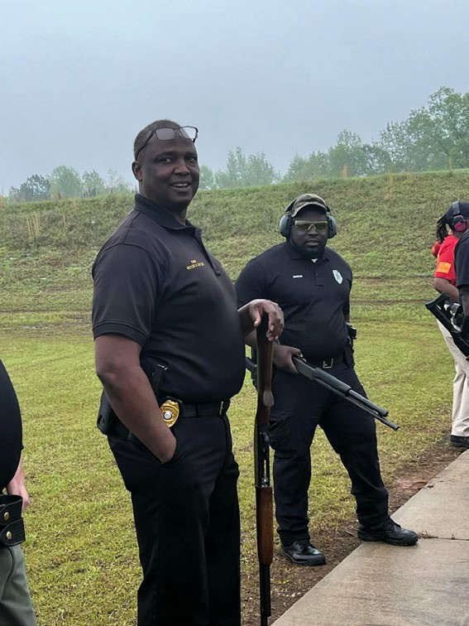

Road Patrol

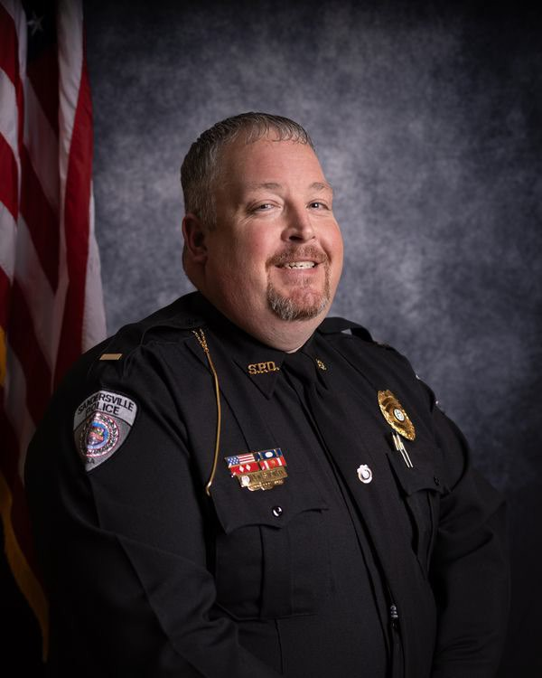
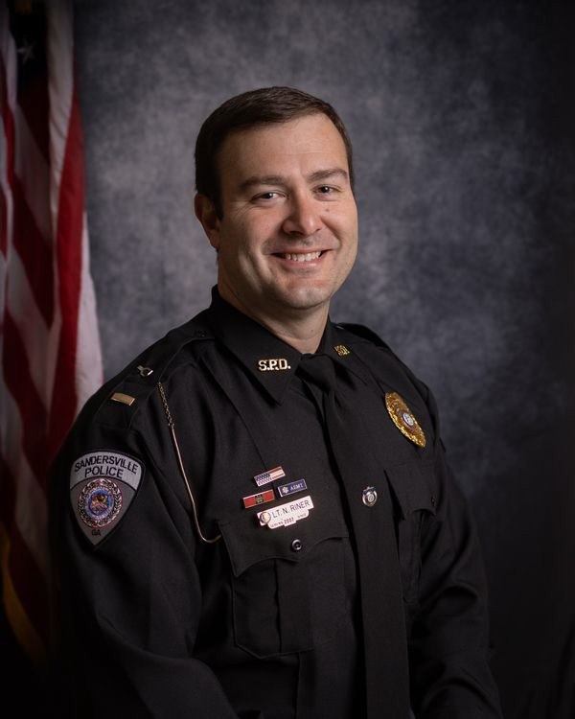
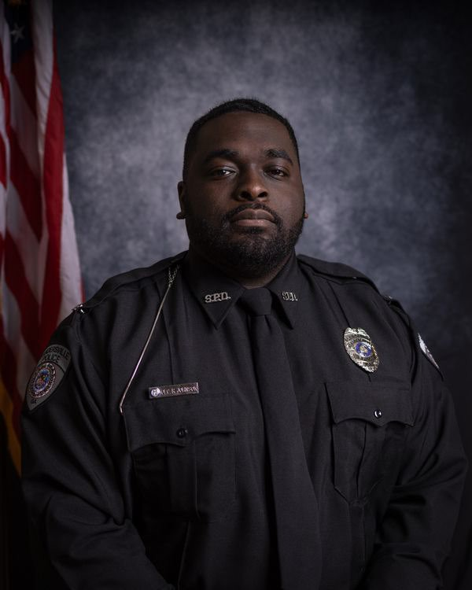
Lt. Wes Howell Lt. Nathan Riner Sgt. Ranquez Johnson

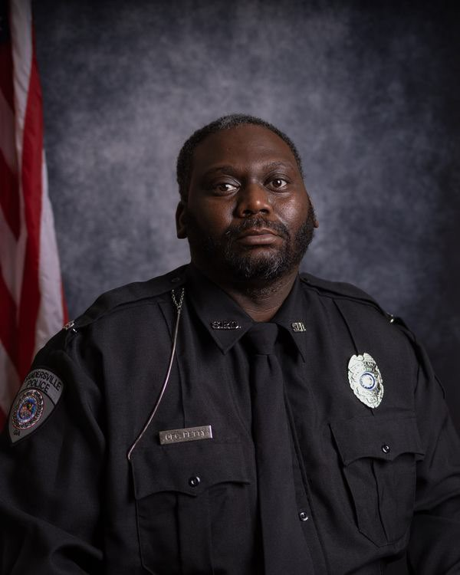
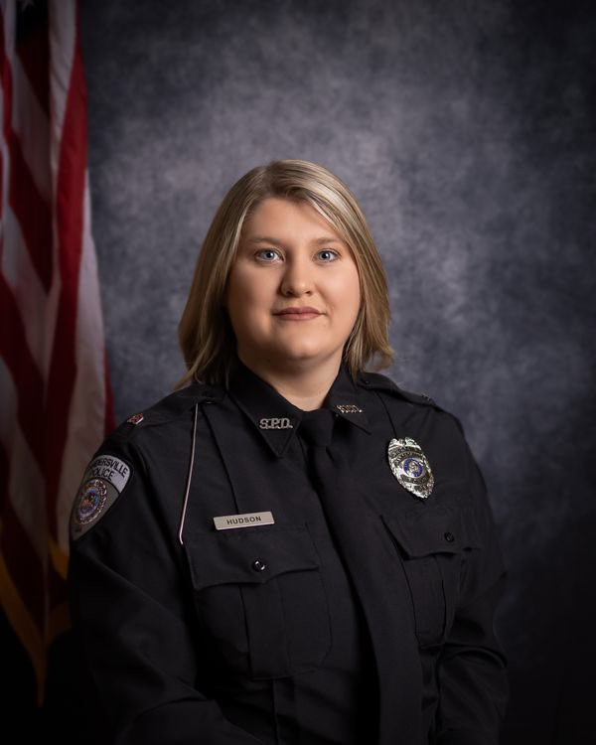
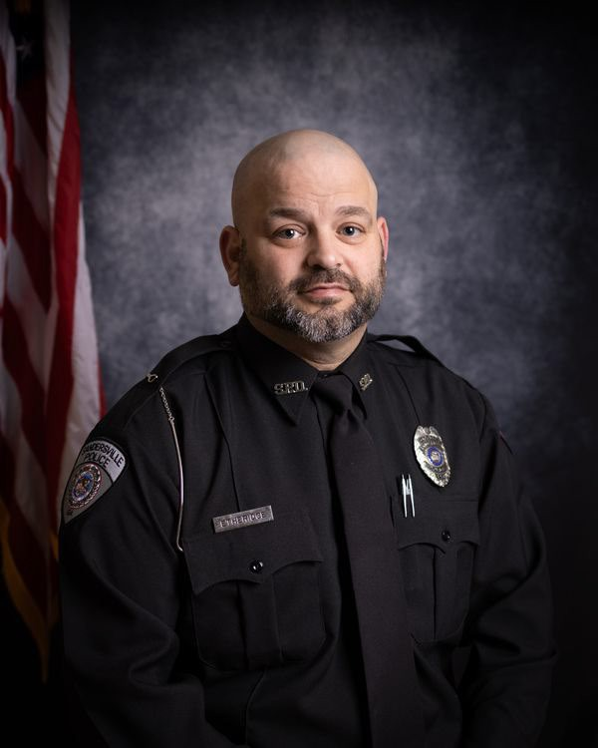
Sgt. Devonte Petty Sgt. Taylor Hudson Sgt. Joseph Courtien

Supervisors

Road Patrol Officers

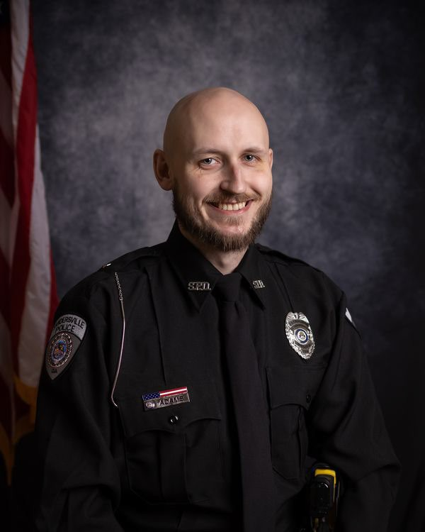
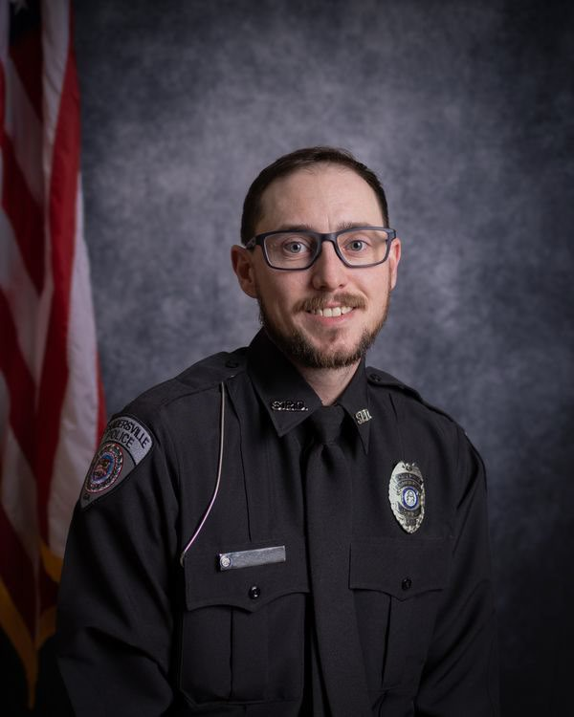
Ofc. John Adams Ofc. Nickolas Campbell

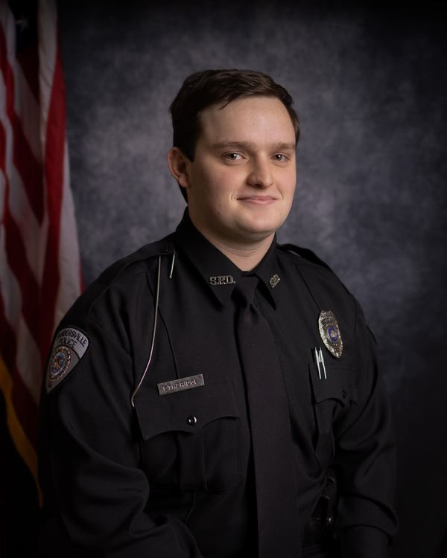
Ofc. Lawson Etheridge

Part Time- Road Patrol Officers

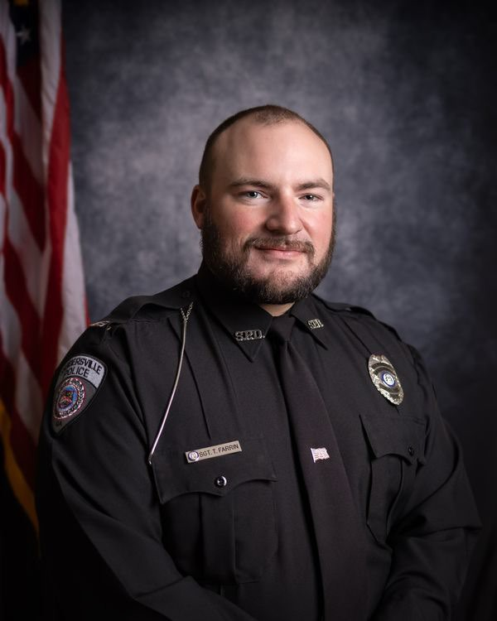

Ofc. Travis Farrin Ofc. Caleb Wiggins

The following Officer not shown

Lt. Ken Parker

Ofc. Brinson

Vehicle Pursuit Analysis

This report is a review and analysis of the Sandersville Police Department’s vehicle pursuits covering the time frame of January 1, 2025 through December 31, 2025. This report intends to analyze the data to identify trends and see if the department’s Standard Operating Procedures (S.O.P.’s) are reflective of department practices.
The Sandersville Police Department conducted a review of vehicle pursuit incidents occurring between January 1, 2025, and December 31, 2025. During the review period, the department conducted 1,482 traffic stops and reported zero (0) vehicle pursuits.
The absence of vehicle pursuits during the reporting period reflects the department's commitment to public safety, risk management, and adherence to established vehicle pursuit policies. By avoiding unnecessary pursuits, officers reduced the potential risks associated with high-speed vehicle operations, including injuries to officers, suspects, and innocent motorists.
A review of department records indicates that officers effectively utilized alternative enforcement and investigative methods when appropriate, including obtaining vehicle information, identifying suspects through investigative follow-up, and coordinating with neighboring law enforcement agencies. These practices support the department's objective of balancing apprehension of offenders with the preservation of life and property.
The analysis further demonstrates that department personnel exercised sound judgment when evaluating the necessity of initiating or continuing vehicle pursuits. The absence of pursuits also resulted in no pursuit-related crashes, injuries, property damage incidents, or citizen complaints related to pursuit activities.

Findings
- Total Traffic Stops Conducted: 1,482
- Total Vehicle Pursuits: 0
- Pursuit-Related Crashes: 0
- Pursuit-Related Injuries: 0
- Pursuit-Related Property Damage Incidents: 0
- Pursuit-Related Citizen Complaints: 0

Conclusion
Based on the data reviewed, the Sandersville Police Department's vehicle pursuit practices during 2025 were consistent with department policy and accepted law enforcement risk-management principles. The department experienced no vehicle pursuits, resulting in no pursuit-related injuries, crashes, or liability concerns. Continued training on pursuit decision-making, legal considerations, and alternative apprehension strategies is recommended to maintain this positive outcome and ensure continued compliance with departmental policy and Georgia law.

Recommendation: Continue annual review of vehicle pursuit incidents and policy compliance, along with periodic training on pursuit management and alternative enforcement strategies, to ensure the department maintains a safe and effective approach to vehicle pursuit operations.

Every vehicle pursuit is reviewed by the Chief of Police. This review of each pursuit is to identify compliance with the departmental Standard Operation Procedures, and state laws. This annual review and analysis have identified the need for a more thorough review of the pursuits. The Chief of Police is committed to a strict compliance of policy in these high liability areas.
After careful review the Chief is satisfied with the criteria set in the SOP to engage in a pursuit. Training is taking place to prepare supervisors to better understand how to conduct a review.



CID DETECTIVES


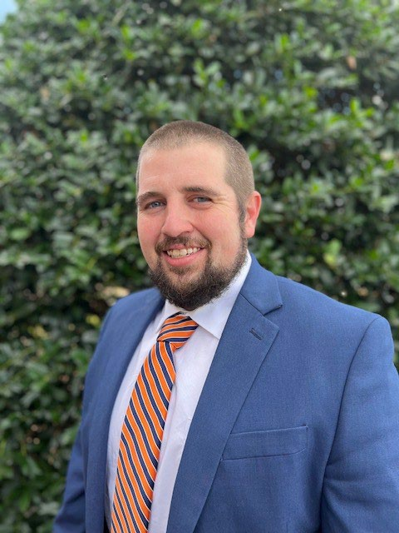
Detective Maceo Ball Detective Brian Dudley

The Criminal Investigations Division (CID) serves as the primary investigative component of the Sandersville Police Department and is responsible for conducting thorough, professional, and objective investigations of criminal offenses occurring within the City of Sandersville. The Division is dedicated to identifying, apprehending, and assisting in the successful prosecution of individuals responsible for criminal activity while ensuring justice for victims and the community.
CID investigators utilize a comprehensive investigative approach that includes interviewing victims, witnesses, and suspects; processing and analyzing crime scenes; collecting and preserving physical and digital evidence; and tracing stolen property, vehicles, and other items connected to criminal offenses. Through the application of advanced investigative techniques, attention to detail, and collaboration with local, state, and federal partners, investigators work diligently to establish the facts surrounding each case.
The responsibilities of the Criminal Investigations Division extend beyond solving crimes. Investigators are tasked with preparing detailed reports, organizing evidence, and compiling complete case files for presentation to the District Attorney's Office. This critical partnership ensures that prosecutors are provided with the information necessary to make informed charging decisions and effectively pursue criminal cases through the judicial process.
The ultimate mission of the Criminal Investigations Division is to seek the truth, uphold the law, and ensure that offenders are held accountable. Through professional investigative practices and unwavering commitment to justice, CID strives to develop cases that prove beyond a reasonable doubt in a court of law that an offender committed the crime for which they are charged.
The Criminal Investigations Division remains committed to protecting the citizens of Sandersville through diligent investigations, victim-centered services, evidence-based policing, and the pursuit of justice. By combining experience, integrity, and professionalism, CID plays a vital role in enhancing public safety and maintaining community trust.



CID CASES



TRAFFIC UNIT

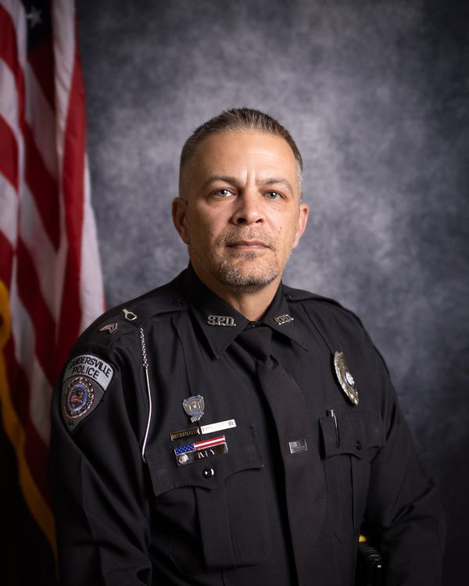
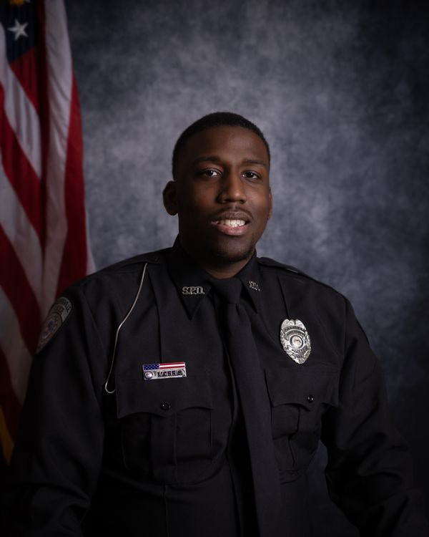
Ofc. Matt Ivey (T1) Ofc. Christopher Morris (T2)

A law enforcement Traffic Unit in Georgia is a specialized team responsible for ensuring road safety, deterring aggressive driving, and investigating severe motor vehicle collisions. These units enforce state traffic laws using radar/lidar speed detection, conduct DUI checkpoints, and often use marked cars or motorcycles.

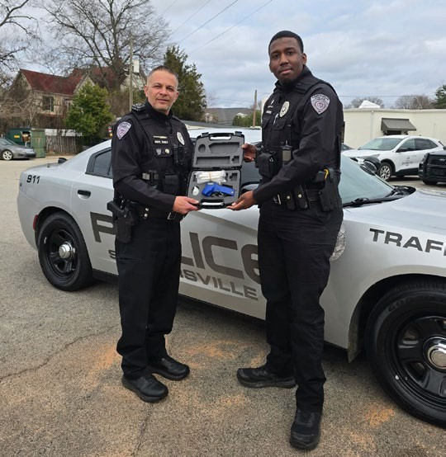

TRAFFIC UNIT

The Sandersville Police Department conducted proactive traffic enforcement activities throughout 2025 to improve roadway safety, reduce traffic-related injuries, and enhance compliance with Georgia traffic laws. The department issued citations, warnings, and conducted enforcement efforts targeting hazardous driving behaviors known to contribute to traffic crashes and injuries.
During the reporting period, officers conducted approximately 1,482 traffic stops and issued a total of 1,482 enforcement actions, including citations, warnings, and arrests.

Enforcement Activity Summary
Enforcement Category | Total
Speeding Citations | 61
Seat Belt Citations | 57
Child Restraint Citations | 2
Uninsured Motorist Citations | 18
DUI Arrests | 15
Suspended/Revoked License Arrests | 10
Distracted Driving Citations | 11
Other Citations | 150
Other Felony Arrests | 9
Stolen Vehicles Recovered | 6
Crash Reports Investigated | 218
Warnings Issued | 1,017

Analysis of Enforcement

The majority of enforcement activity consisted of warnings (1,017), demonstrating the department's commitment to voluntary compliance through education and corrective action. Officers utilized discretion to address minor violations while maintaining a visible enforcement presence throughout the city.
Speeding violations (61) and seat belt violations (57) represented the most significant traffic safety concerns identified during the year. These violations are recognized contributing factors in serious traffic crashes and remain an enforcement priority.
The department also addressed impaired driving by making 15 DUI arrests, removing potentially dangerous drivers from the roadway and reducing the risk of alcohol-related crashes.
Enforcement efforts against uninsured motorists resulted in 18 citations, while 10 drivers were arrested for operating vehicles with suspended or revoked licenses. These enforcement actions promote accountability and compliance with Georgia motor vehicle laws.
Officers issued 11 distracted driving citations, reinforcing the department's commitment to reducing crashes caused by driver inattention and mobile device use.

Crash Analysis

The department investigated 218 traffic crashes during the reporting period. Continued enforcement of speeding, impaired driving, occupant protection, and distracted driving laws remains critical to reducing crash frequency and severity.
The recovery of six stolen vehicles further demonstrates the effectiveness of proactive traffic enforcement as a tool for identifying criminal activity and recovering stolen property.

Findings
- Traffic enforcement remained focused on education and voluntary compliance.
- Speeding and seat belt violations were the most common targeted safety violations.
- DUI enforcement efforts contributed to safer roadways by removing impaired drivers.
- Traffic stops continued to serve as an effective crime prevention and criminal interdiction tool.
- No reckless driving citations were reported during the review period.
- The high number of warnings issued reflects a balanced enforcement approach emphasizing public education.

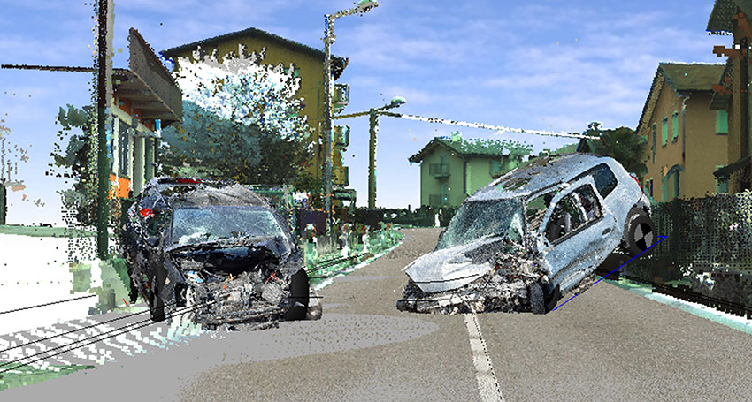

Conclusion
The Sandersville Police Department's 2025 traffic enforcement efforts were consistent with its mission to enhance public safety through proactive enforcement, education, and crash reduction strategies. Officers maintained a strong traffic safety presence while utilizing enforcement discretion to encourage compliance with traffic laws. Continued emphasis on speeding enforcement, occupant protection, impaired driving detection, and distracted driving enforcement is recommended to further improve roadway safety and reduce traffic-related injuries and crashes within the community.

Recommendations

- Continue targeted speeding enforcement in high-crash areas.
- Maintain DUI enforcement initiatives and officer training.
- Increase public education regarding seat belt usage and distracted driving.
- Conduct periodic traffic safety campaigns in coordination with Georgia highway safety initiatives.
- Continue annual analysis of traffic enforcement data to identify trends and allocate resources effectively.

Animal Control Officers

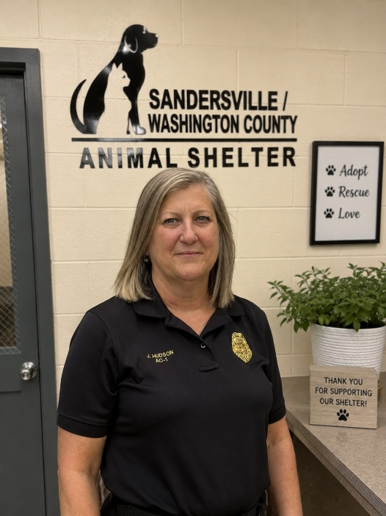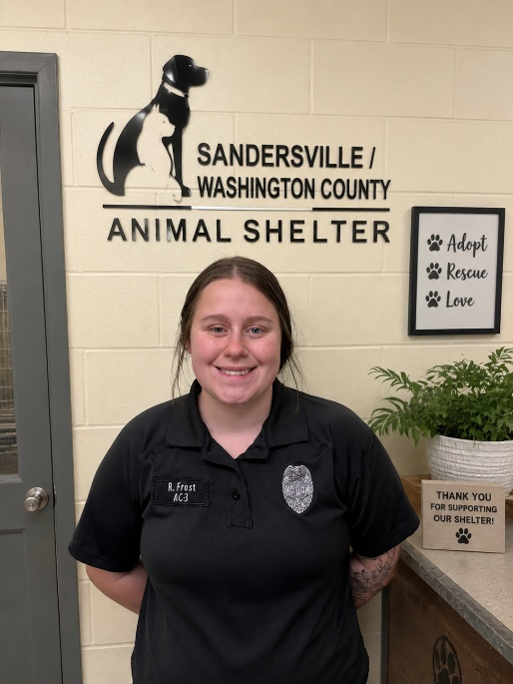
AC1 Jennifer Hudson AC2 Rachel Frost

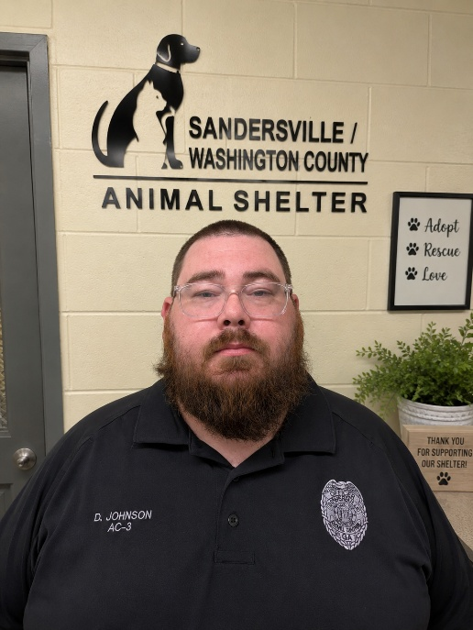
AC3 Derek Johnson

The Sandersville/Washington County Animal Control Division is responsible for protecting the public, enforcing animal-related laws and ordinances, and ensuring the humane treatment of animals throughout the community. The division operates the local animal shelter and works closely with law enforcement, veterinarians, rescue organizations, and the public.

Mission Statement
The Sandersville/Washington County Animal Control Shelter is responsible for the collection and care of stray, vicious, neglected, and abused animals. The division strives to protect public safety, promote responsible pet ownership, provide humane treatment of animals, and place adoptable animals into safe and caring homes whenever possible.

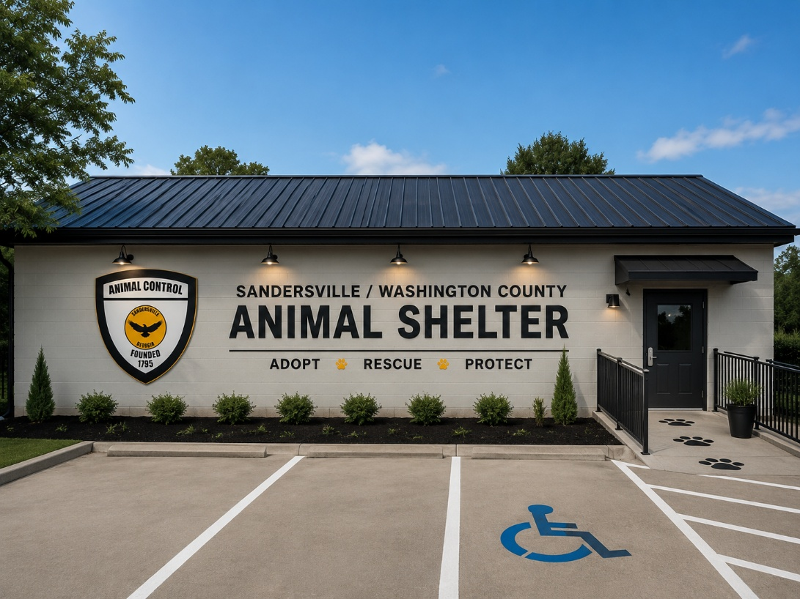

Animal Control 2025 Cases





State Certification

Certification Manager

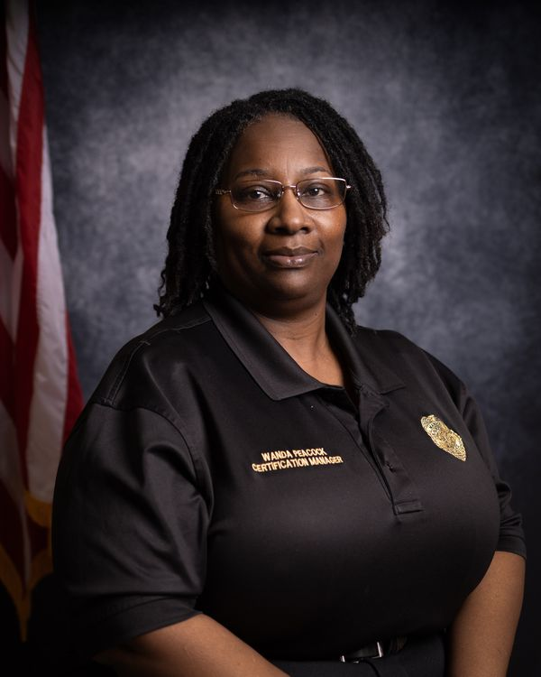

Lt. Wanda Peacock is the department’s Evidence Technician Specialists and State Certification Manager. Lt. Peacock’s duties include cataloging and safekeeping of
evidence and property as well as returning property to its rightful owners.
As the State Certification Manager, Lt. Peacock maintains State Certification files. She also ensures yearly compliance with State Certification files, coordinates mock and on-site State Certification assessments, maintains schedule of Policy reviews, reviews all
departmental policies for compliance to State Certification Standards, develops and oversees testing on Policy updates and reviews, generates and submits State Certification Annual Compliance Report, generates and submits Annual Pursuit Report to GACP by March 1st of each year, generates / updates and submits statistical reports, attends departmental meetings, completes assignments / special projects as directed, works assigned patrol shifts on an as needed basis and performs other related duties as assigned.

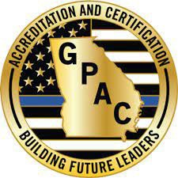

WHAT IS STATE CERTIFICATION?

Certification status represents a significant professional achievement for a law enforcement agency. Certification acknowledges the implementation of policies and procedures conceptually sound and operationally effective. The Certification Program provides a comprehensive blueprint for effective, professional law enforcement. Program staff at the GACP are prepared to make their knowledge, experience, and resources available to help your agency become certified. We encourage you to contact us to obtain more information on the program. It is the role of the Georgia Law Enforcement Certification Program to establish standards promoting professionalism in law enforcement, oversee the State Certification process, and award certification status to Georgia Law Enforcement agencies that meet the established standards.



ADMINISTRATIVE ASSISTANT

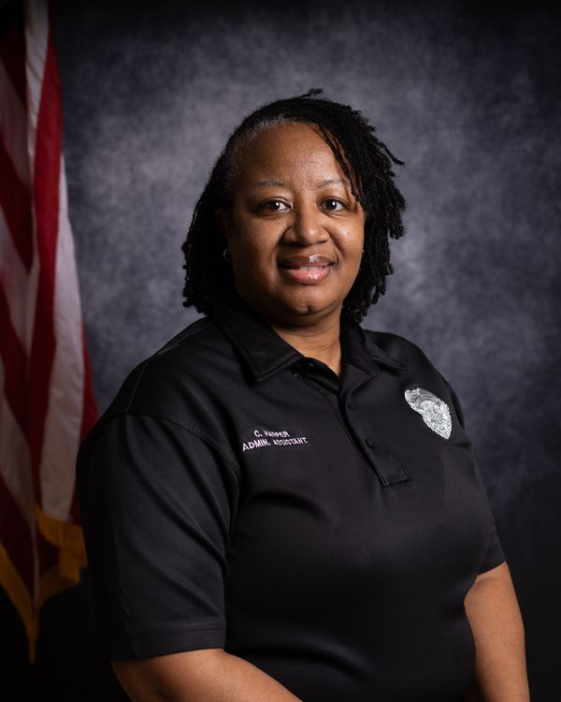

Cassandra Harper is The Administrative Assistant and her job is to complies and posts employee time and payroll data on spreadsheets, manages fingerprinting equipment, manages the department stockroom. She also copies videotapes for the District Attorney’s office. Cassandra Harper processes open records requests. She also prepares uniforms crime reports, creates access cards for new employees, and answers telephone and greets visitors: provides information and assistance.
Operates Georgia Crime Information (GCIC) and National Crime Information Center (NCIC) terminals.



COMMUNITY RELATIONS

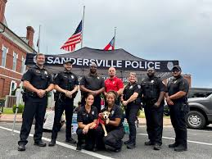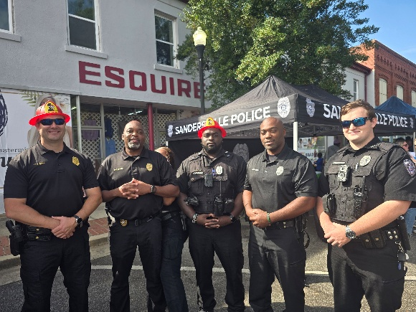

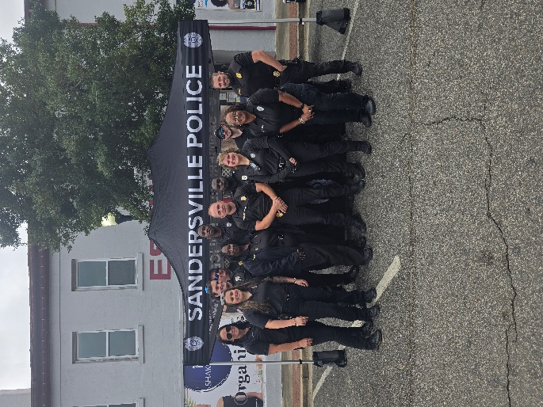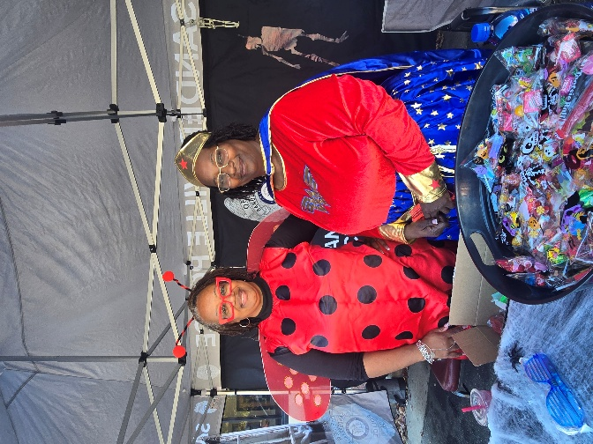

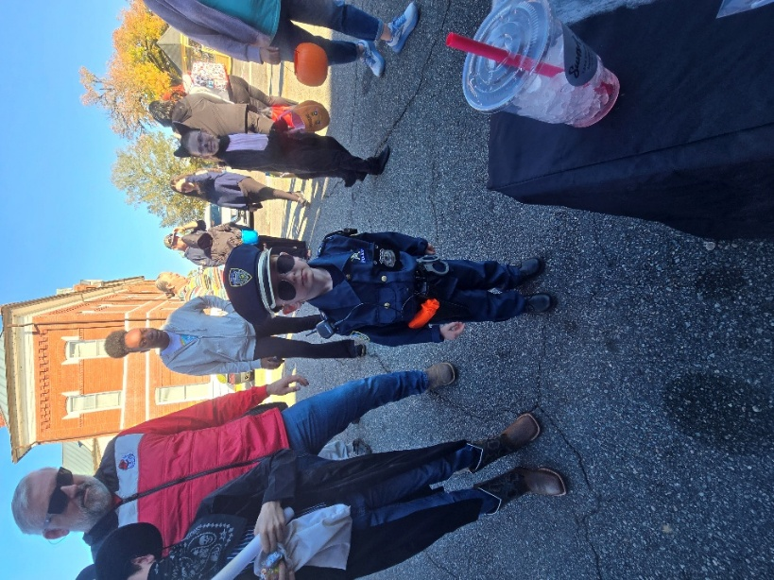

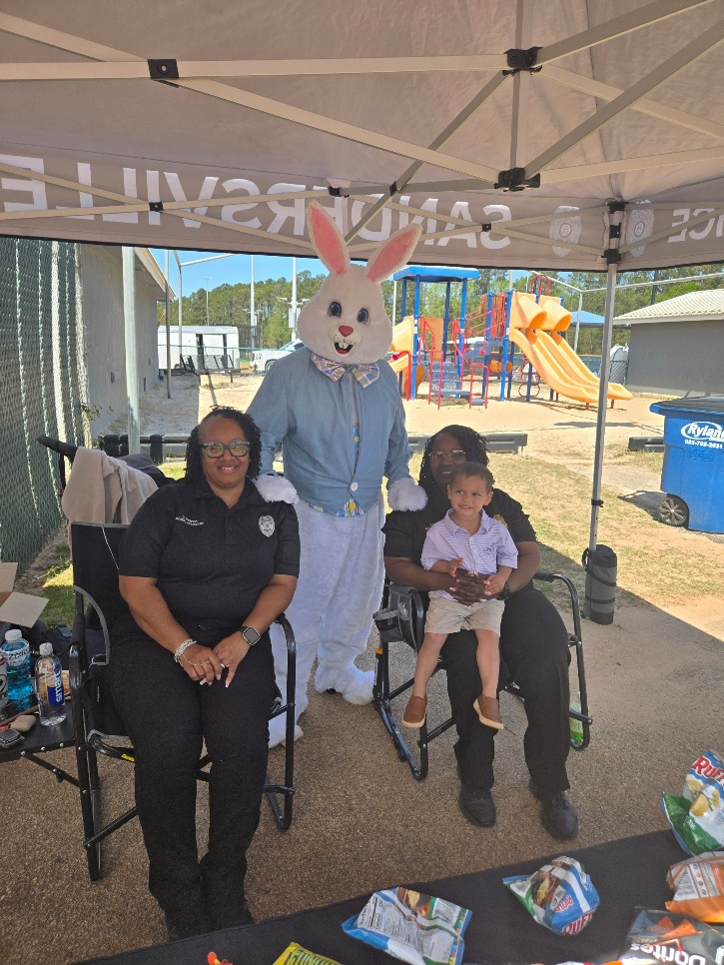
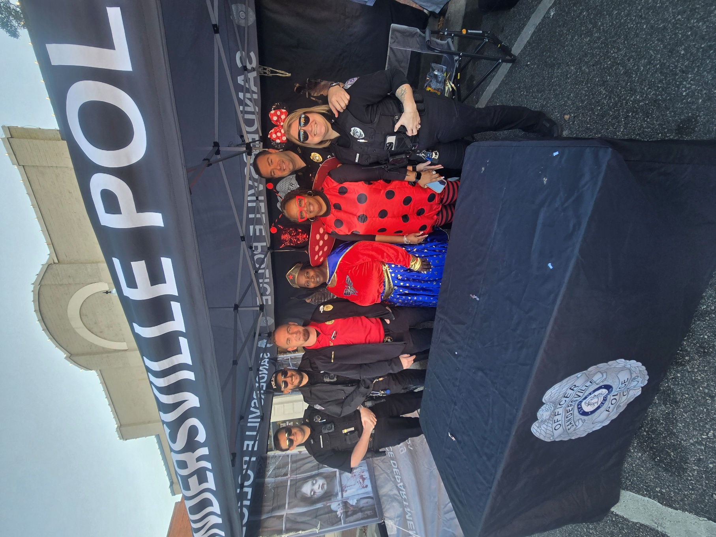

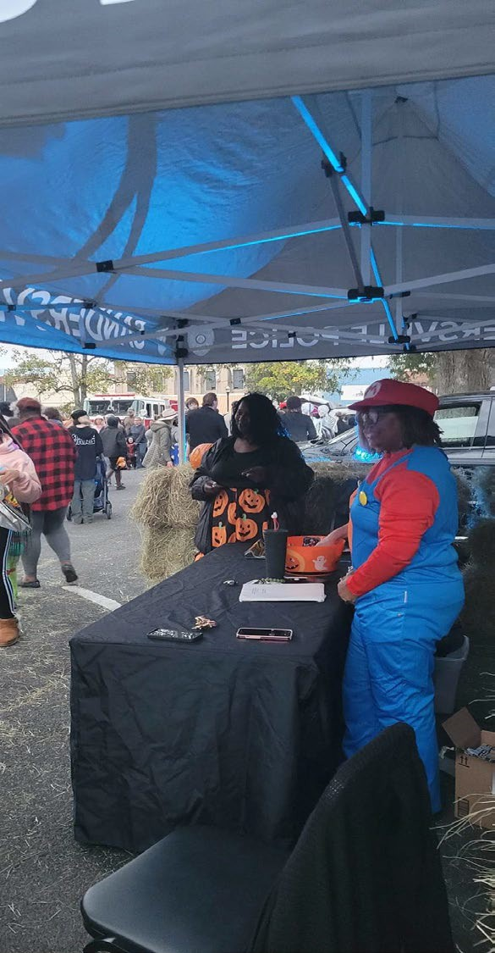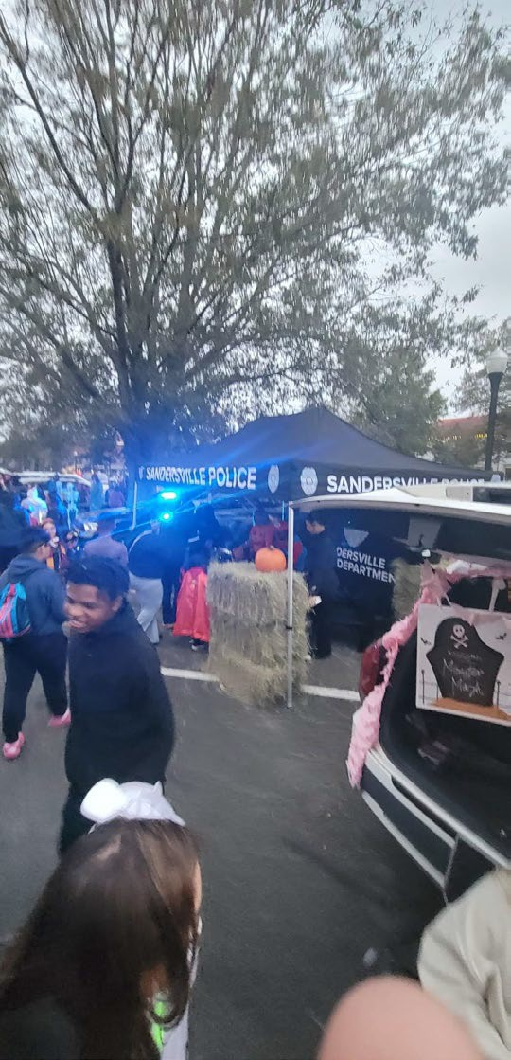



Public Safety Day

